**Front-End UI/UX Mini Project**

**Project Submission Template**

**1. Title Page**

* **Project Title**: *Fashion Lookbook Website*
* **Submitted By**:

|  |  |  |
| --- | --- | --- |
| **FULL NAME** | **ROLL NUMBERS** | **COLLEGE EMAIL ID** |
| Aleena Tomy | 2460318 | aleena.tomy@btech.christuniversity.in |
| Arnima Guha | 2460337 | arnima.guha@btech.christuniversity.in |
| Rosepriya Franci George | 2460437 | rosepriya.franci@btech.christuniversity.in |

* **Course**: *UI and UX Developer*
* **Instructor Name**: *Narendrakumar Gopineedi*
* **Institution**: *Christ University*
* **Date of Submission**: *12/08/2025*

**2. Abstract**

*This project involves creating a visually-driven, single-page* ***Fashion Lookbook Website*** *to showcase a brand’s seasonal collection with immersive galleries. The key goal is to design a high-end, minimalist aesthetic that maintains brand consistency while delivering strong visual impact. Core technologies include* ***CSS Grid*** *for complex gallery layouts,* ***object-fit/position*** *for precise image cropping, and* ***scroll-triggered animations*** *using CSS @keyframes. The site features sections like a hero with video/parallax, collection gallery, trend spotlight, brand story, and a styled store locator. The final outcome will be a responsive, magazine-style website optimized with ultra-high-resolution images, offering an elegant and engaging experience for users, enhancing brand presence and appeal in both desktop and mobile views.*

**3. Objectives**

* ***Create a high-end, visually impactful website*** *that reflects a premium fashion brand identity.*
* ***Implement advanced CSS techniques*** *such as Grid layouts, parallax scrolling, and hover effects to enhance user engagement.*
* ***Maintain brand consistency*** *through minimalist design, monochromatic color schemes, and magazine-style typography.*
* ***Ensure responsive and optimized performance*** *across devices with ultra-high-resolution images and adaptive layouts.*
* ***Deliver an immersive user experience*** *through scroll-triggered animations, interactive galleries, and stylish content presentation.*

**4. Scope of the Project**

* *Focused entirely on* ***front-end design****, ensuring clean, lightweight, and fast-loading pages.*
* *Maintains a* ***static structure*** *for simplicity and ease of deployment.*
* *Store locator kept* ***minimal and direct*** *for quick reference.*
* *Uses* ***pure HTML, CSS, and JavaScript*** *to highlight core web design skills without framework dependency.*
* *Flexible* ***placeholder media*** *allows easy customization for any brand’s assets.*

**5. Tools & Technologies Used**

|  |  |
| --- | --- |
| *Tool/Technology* | *Purpose* |
| *HTML5* | *Markup and content structure* |
| *CSS3* | *Styling and layout management* |
| *VS Code* | *Code editor* |
| *Chrome DevTools* | *Testing and debugging* |
| *JavaScript* | *Interactivity and dynamic elements* |

**6. HTML Structure Overview**

* *Used semantic tags: <header>, <nav>, <main>, <section>, <footer>*
* *Organized into clear sections: Hero, About, Gallery, Store Locator, Contact*
* *Navigation menu created with <ul> and anchor links for quick section access*
* *Footer includes social media links and copyright information*

**7. CSS Styling Strategy**

* *Used external CSS file (style.css)*
* *Organized with clear comments and section divisions*
* *Flexbox and Grid for responsive layout structure*
* *Media Queries to adapt design for different screen sizes*
* *CSS Variables for easy color and font customization*
* *Hover effects, transitions, and animations for interactivity*
* *Mobile-first design approach for better accessibility on small devices*

**8. Key Features**

|  |  |
| --- | --- |
| *Feature* | *Description* |
| *Responsive Design* | *Adapts seamlessly to all screen sizes, ensuring a consistent high-fashion experience on mobile, tablet, and desktop* |
| *Smooth Navigation* | *Fixed top navigation bar with anchor links for quick access to sections* |
| *Lookbook Gallery* | *Grid/Flex-based layout showcasing images with hover animations for a premium feel* |
| *Store Locator (Placeholder)* | *Layout prepared for map integration to find store locations* |
| |  | | --- | | ***Contact Form (non-functional)*** |  |  | | --- | |  | | |  | | --- | | *Styled input fields and button for future contact feature integration* |  |  | | --- | |  | |
| |  | | --- | | ***Accessible Fonts & Colours*** |  |  | | --- | |  | | *Elegant typography and high-contrast palette for readability and brand identity* |

**9. Challenges Faced & Solutions**

|  |  |
| --- | --- |
| *Challenge* | *Solution* |
| |  | | --- | | ***Ensuring responsive design across all devices*** |  |  | | --- | |  | | |  | | --- | | *Implemented mobile-first CSS with media queries and tested layouts on different screen sizes* |  |  | | --- | |  | |
| |  | | --- | | ***Smooth navigation without page reloads*** |  |  | | --- | |  | | |  | | --- | | *Used anchor links and fixed navigation bar for quick section access* |  |  | | --- | |  | |
| |  | | --- | | ***Styling while keeping the code organized*** |  |  | | --- | |  | | *Created a* ***dedicated external CSS file*** *with clear section comments* |

**10. Outcome**

* *Developed a* ***responsive and visually engaging*** *high-fashion lookbook website.*
* *Implemented* ***smooth navigation and interactive elements*** *for better user experience.*
* *Maintained a consistent luxury brand identity with cohesive design and styling.*

**11. Future Enhancements**

* *Integrate a* ***functional store locator*** *with Google Maps API.*
* *Add a* ***dynamic product gallery*** *with filtering and sorting options.*
* *Implement* ***e-commerce features*** *like cart, wishlist, and secure checkout.*

**12. Sample Code**

*(Screenshot showing the start of the* Kallos *HTML file, where Google Fonts are linked and CSS root variables are defined for colors, layout, and typography, setting up the base styling for the fashion lookbook website.)*

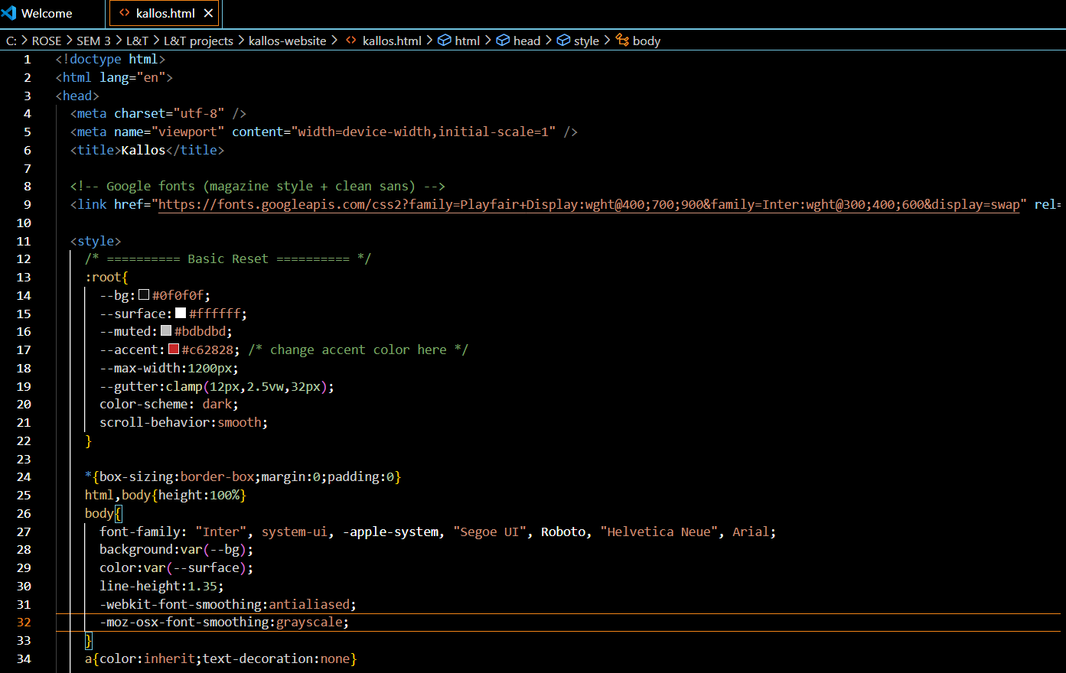

*(Screenshot showing the 'Trend Spotlight' and 'About the Brand' sections of the* Kallos *HTML page, where featured fashion items are displayed with images, titles, and descriptive text, styled for a high-fashion lookbook layout.)*

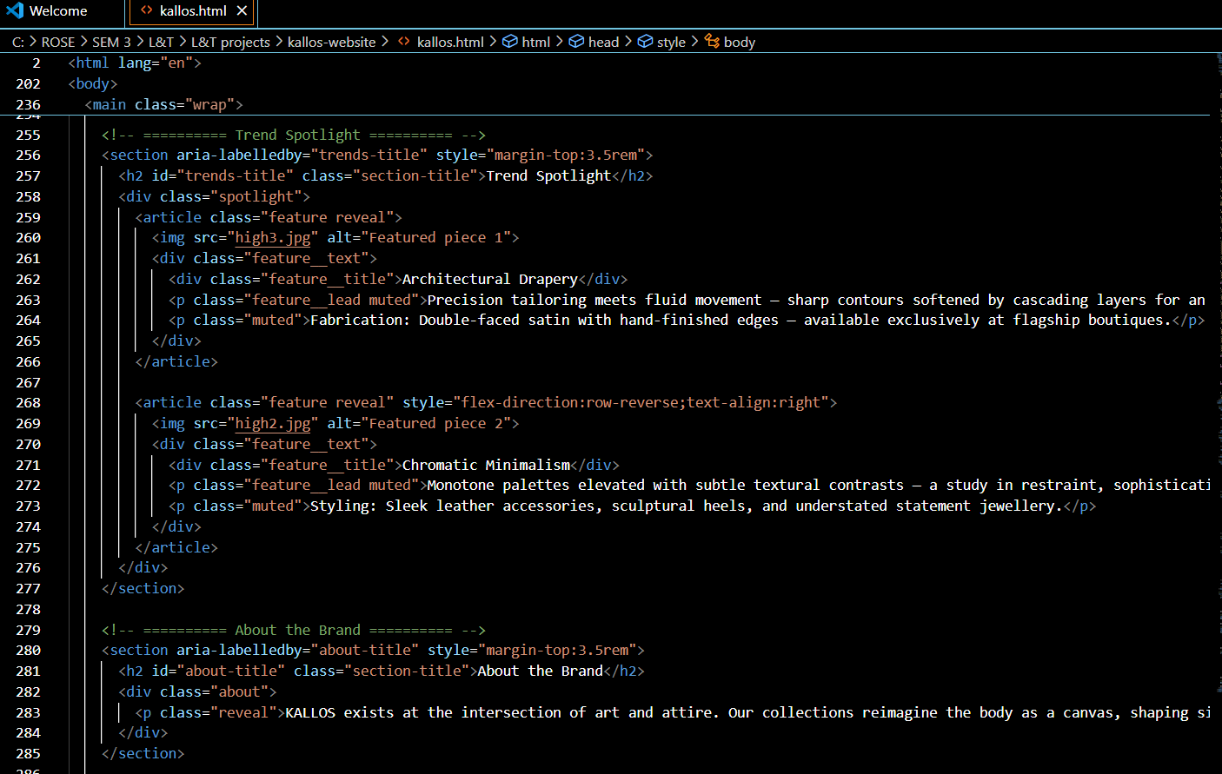

**13. Screenshots of Final Output**

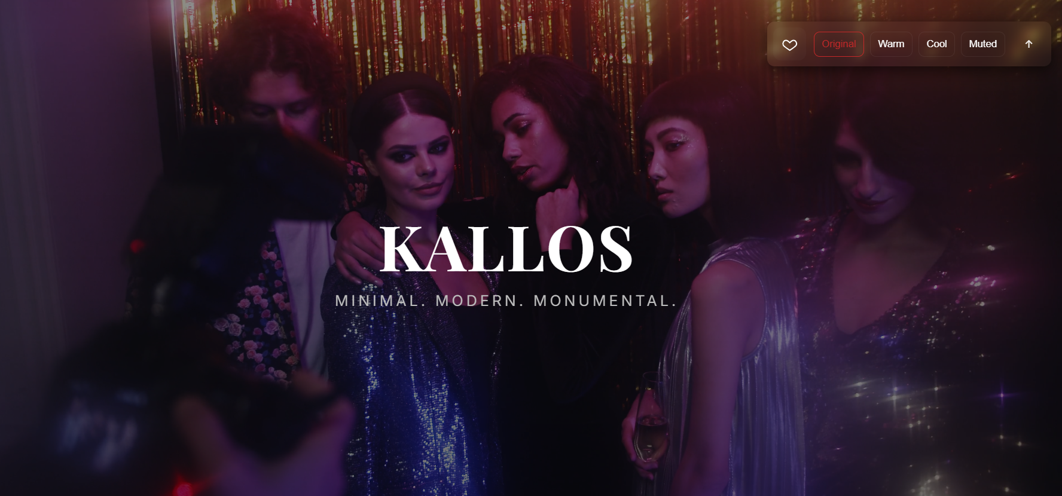

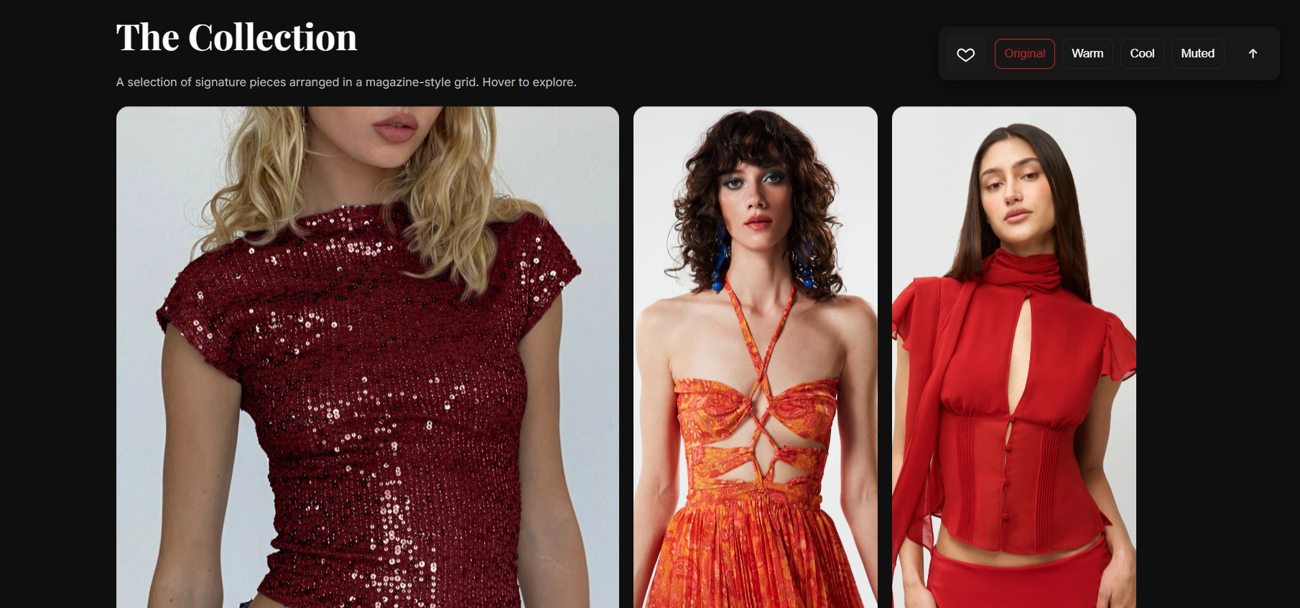

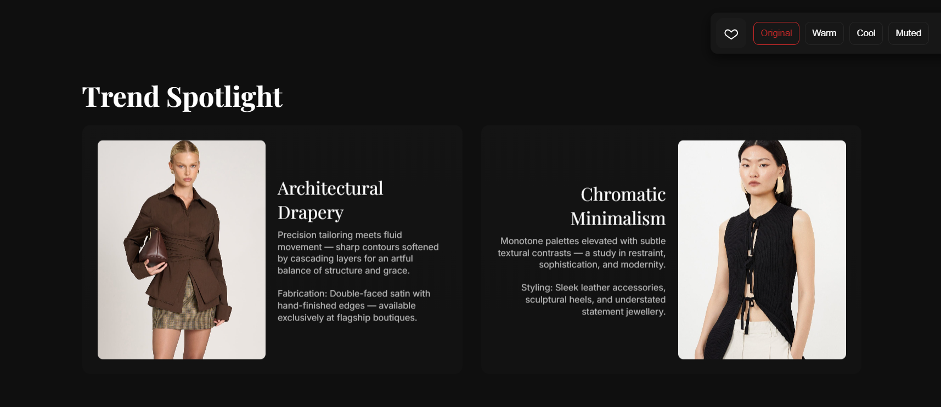

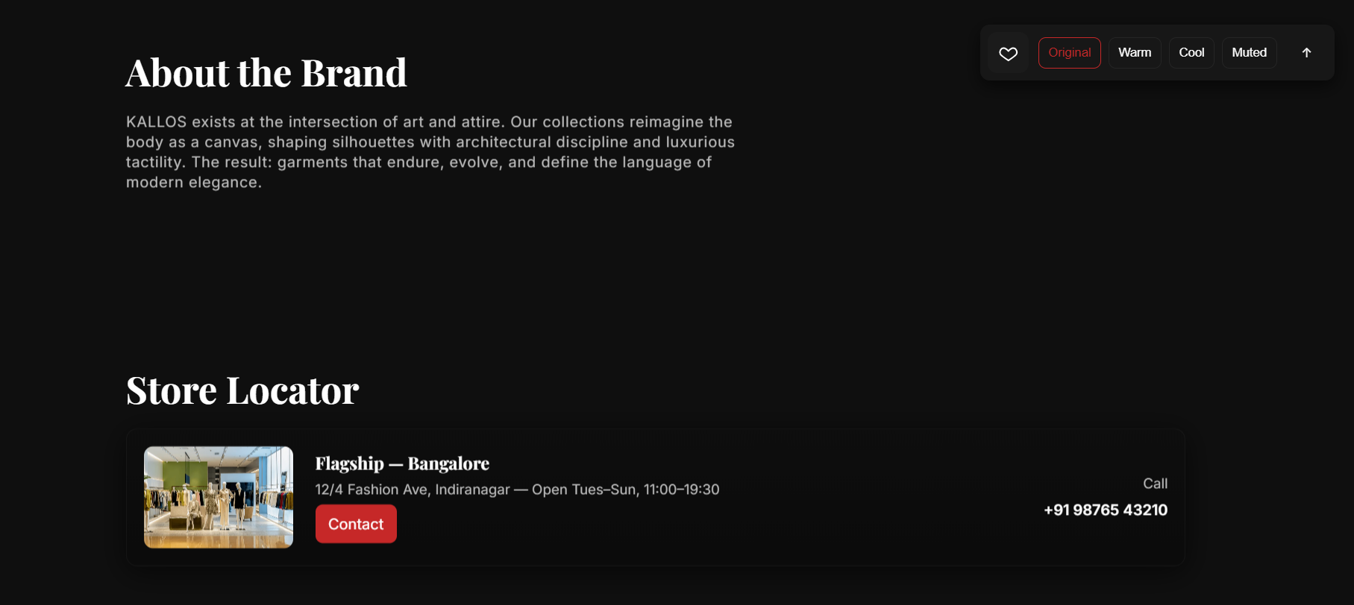

**14. Conclusion**

*Our project is a high-fashion, visually immersive lookbook website designed to showcase a brand’s seasonal collection with striking imagery and elegant descriptions. I structured the content using semantic HTML and accessibility features like ARIA labels to ensure clarity and inclusivity. Through this project, we learned how to pair visuals with compelling text to tell a brand story, prepare HTML for advanced CSS techniques, and organize layouts for responsiveness across devices. We also gained experience in translating a luxury brand’s aesthetic into a digital format, focusing on typography, layout, and tone to create an engaging, upscale user experience.*

**15. References**

L&T LMS : https://learn.lntedutech.com/Landing/MyCourse